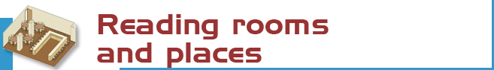

148 reading seats distributed as follows:

- Reading room: 108 seats
- Research room: 46 seats
- Media library: 4 seats



Books: The books are in storage and must be requested at the loan desk (DP, BI, CR, …+ number signatures)

Journals : the latest numbers are available on shelves on the reading rooms. Earlier copies can be found on restricted access shelves and should be requested at the loan counter. (FSL + number signature)

Special materials (CD, DV…+ number): Are located in the Research room (reference library in Cd, dvd: MCD + number signarure) or in the reading room (O, O Sala + number signatures)

Reference books: Are located in the reading room in free access

For other materials please consult: www.ucm.es/bucm/fsl



- Books: 110.288  - Journals: 669 titles  - Special materials (CD, DV, DQ, VI, CDP): 775 items | The catalogue code indicates where the title can be found.  For example, DP16HEG  - The first letters indicate the collection (in this case DP: deposit books on Spanish Language)  - The numbers indicate the subject (16=Logic)  - And the last letters represent the author (HEG: Hegel)


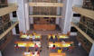 | The Complutense Library is the biggest university library in Spain, with 33 faculty libraries, 11.200 reading places, 3,000,000 of titles, 1,200 computers, and most importantly a staff of 467 people at your service.

 | 

COMPLUTENSE UNIVERSITY OF MADRID Library

http://www.ucm.es/BUCM/fsl/

guide | 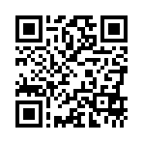  Philosophy

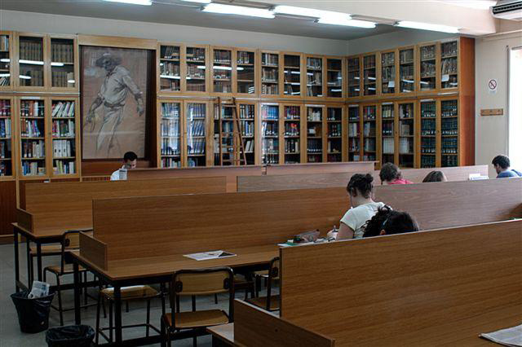

LIBRARY HOURS:  School days: 09.00 to 21.00.  Special timetables apply during exam periods, Christmas, Easter and in summer, to be announced in advance.  Address:  Biblioteca de Filosofía Edificio A 2ª planta  Ciudad Universitaria s.n.  28040 Madrid  Tel:  • Library Information: 913945250  • Loans: 9139475358 / B: 913945527  • Inter-library loans: 913945250  • Technical procedure: 913945250  • Sub-directorate: 913945250  • Directorate: 913945257  Fax: 91-3945527  E-mail: buc_fsl@buc.ucm.es | Transport  METRO  - Line 6: Ciudad Universitaria.  E.M.T. BUSES  - Lines F, G, U, I, 82, 83, 132
More information at the help desks, our website, our blog BlogSophia and Facebook

November 2011



We will answer your queries about finding information, carrying out searches, using electronic documents and databases:
In person: At the help desks.
In our website: “Ask us” and chat
By telephone: 913945250/5527 (school days from 09.00 to 21).
More information and forms at:
- www.ucm.es/bucm/fsl
- www.ucm.es/BUCM/necesitoayuda.php



Who. All members of our university community may use all our services, take out books on loan and access our online collections off campus. Members of the UCM Alumni Association and Friends of the UCM have access to some of our services such as home loan.

Our materials can be used by everybody in the reading rooms (restrictions may be in force during examination periods). Visitors who wish to use other services or borrow books must be recognised by a professor or by the Director of the Library by means of a valid library card, which is personal and non-transferable. For some services a PIN number is required.

Improper use of materials or inappropriate behaviour towards our staff or other users constitutes gross misconduct and will be dealt with by academic or legal authorities (Library Rules).



The library organizes occasional guided tours and by prior arrangement to further awareness of its services. In addition, visits are made to class groups of teachers request. Also have you all the information on activities, funding and services on our website: http://www.ucm.es/BUCM/fsl/index.php

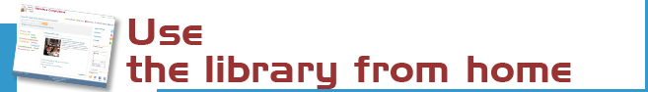

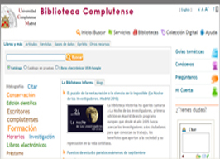 | Our website enables you to:  - Renew and reserve loan books.  - Access our electronic resources  - Consult a librarian (chat…)  - Use guides.  - To keep informed and participate via our blogs.  - Select and save your searches  - Propose the purchase of a book …  Some services require PIN.


Loan conditions:  Reference books (encyclopaedias …), journals, unpublished theses, and works of special value cannot be taken out on loan.  Fines:  One day for each day overdue.  Library Hours: From 9.00 to 20:30. | Deadlines and number of titles:  - Students: 8 titles (15 days).  - Researchers and administrative  personnel: 12 (1 month).  - Teachers: 25 (2 months)  Renewals and reserving.  Reservations and renewals of books in the catalogue may be made using your PIN.



You can use our online service to find out about availability of your course bibliographies.

The Complutense Library will arrange special opening hours at some libraries during examination periods (Saturdays, Sundays, at night).

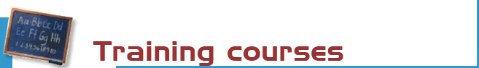

The library organizes free courses on the use of its online resources.
More information regarding membership, etc. can be found at the web (electronic forms), at the help desks and at buc_fsl@buc.ucm.es

Courses:
- Use of catalogues, databases and online journals.
- Advanced use of information resources for research in information technology and related sciences.
-Courses on demand, on request
Our website offers guides for using our resources.



Our computers are available for public use to access the Internet and search our online collections. The library offers Wifi Internet access through the UCM network.
We also have 5 laptops with wireless access on loan at the reading room.
Library Hours: from 9.00 to 20.30



There is a Photocopying service for public use at the Faculty, located in the basement. In addition the library has a self-service photocopying for teachers and researchers.



The bibliography service can help you find referenced books and documents, articles deposit in the e-prints server, advice on teaching and research evaluation…
Stay up to date by subscribing to the e-mail summary and new additions service.



We can obtain documents from other national and international libraries which are not in our collections. See http://www.ucm.es/BUCM/servicios/5836.php



If you would like to publish your research online we can help you through our electronic publishing service.
Working with the UCM Publications Service, we will arrange to publish your theses, journal articles, pre-prints and books: ISBN management …
(buc-edición@buc.ucm.es)



We are making every effort to ensure that our premises are adapted to the needs of disabled persons. There are ramps and lifts that provide access to the library. JAWS and MAGIC software is available for sight-impaired users. We also have a magnifying glass.
More info at buc-discapacidad@buc.ucm.es



Purchase requests. Please let us know which titles we should acquire to complement our catalogue, or which titles need more copies.

Complaints or suggestions. You may complain or make suggestions in person, by e-mail, Ask us option or through chat. We will contact you as soon as possible.

