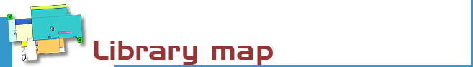

Ground floor:

1st FLOOR:

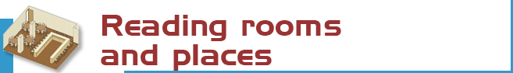
GROUND FLOOR  Journals room: 52 places.  Meeting room: 32 places.  Researchers room: 33 places  Training room: 25 places. | FIRST FLOOR  Reading room: 578 places.  Study rooms: 50 places


The library has more than 160,000 copies of books, journal titles, statistics, working papers, DVD, CD, thesis ...  - Free access collections:  Basic bibliography (sig. S): 16.500  Handbooks (sig. M): 11.500  Reference books (sig. R): 2.200  DVD: 1000 films  - CEDES collections:  books and journals | - Deposit collections:  Books edited before 2000:100.000(D)  Theses: 4.200 (T)  Working papers: 16.000 (W)  Books of the nineteenth century:  1.300 (FA)  Journals: 2.000 titles  Statistics: 200 series  - Full text electronic collections:  Books, journals working papers,  Theses…

The signature is a code that indicates where a book or another material is placed. Example: M336.2ALB
The first letter indicates the collection. In this case M is for manuals
The numbers show the materia. 336.2 means taxes.
After the numbers there are three letters for the surname of the author. ALB IBAÑEZ, Emilio.

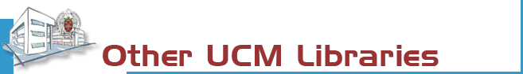

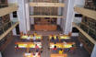 | The Complutense Library is the biggest university library in Spain, with 33 faculty libraries, 12,700 reading places, 3,000,000 of titles, 1,000 computers, and most importantly a staff of 467 people at your service.


COMPLUTENSE UNIVERSITY OF MADRID

Library

http://www.ucm.es/bucm/cee

Guide | 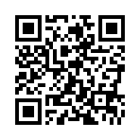  Economics and Business Studies

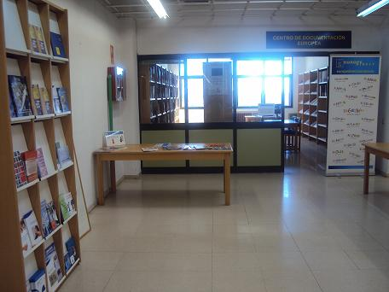
LIBRARY HOURS:  School days: 9 to 21  Special timetables apply during exam periods, Christmas, Easter and in summer, to be announced in advance.  Address:  Campus de Somosaguas s/n  Pozuelo de Alarcón  28223 Madrid  Telephones:  Library Director: 913942608  General information: 913942600  Library information: 913942602 / 2604/ 3056  Loans: 913942654 / 913942586  Interlibrary loans: 913942603  Technical procedure: 913943056  Fax: 913942426  E-mail: buc_cee@buc.ucm.es | Transport:  E.M.T. BUSES  Line A: Moncloa – Campus de Somosaguas  Line H: Aluche – Campus de Somosaguas  Line I. Somosaguas – Campus de Moncloa  Light rail: 2 line Colonia Jardín-Estación de Aravaca (Campus Somosaguas stop)  TRANSPORT CONSORTIUM CAM  (Llorente Company) 562 y 563 Aluche-Pozuelo (stop in the Húmera-Pozuelo road)

October 2012

More information in web, Economía Complutense blog, Facebook, Twitter, Netvibes and Delicious



We will answer your queries about finding information, carrying out searches, using electronic documents and databases:
In person: At the help desks.
By telephone: 913942602 (school days from 9 to 21).
E-mail: buc_cee@buc.ucm.es
Chat: http://www.ucm.es/BUCM/


All members of our university community may use all services and borrow books by means of a valid library card which is personal and non-transferable. For access online to the collections off campus a PIN number is required. Members of the UCM Alumni Association and Friends of the UCM have access to some of our services such as home loan.
Our materials can be used by everybody in the reading rooms (restrictions may be in force during examination periods). Visitors who wish to use other services or borrow books must be introduced by a professor or by the Library Director.
Improper use of materials or inappropriate behaviour towards our staff or other users constitutes gross misconduct and will be dealt with by academic or legal authorities (Library Rules).


The Library organizes several activities aimed at knowledge of the collection and use of services.
- Welcome Week at the beginning of the course, with guided tours, classroom demonstrations, posters, guides ...
- Visits exist for students groups, previous request of the teachers or the interested parties. Registration and further information can be found at the help desks.
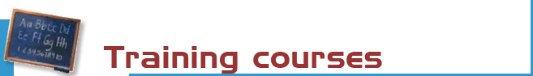

The Library organizes free courses in the morning and afternoon.
- General courses: Use of catalogues, databases and online journals.
- Specialized courses: Information Resources for Economics, Business, and Actuarial Science
- Tailor-made courses on demand
- Free courses with 2 credits or 1ECTS and sessions for teaching and research staff of Campus Somosaguas
- Upgrade sessions for Teaching and Research staff of Campus Somosaguas
On the Web site are published timetable courses and help guides for learning how to use resources and library services.


Books: the most recent and in-demand titles can be found in the open access rooms classified by subjects (codes M and S). The reference books (code R) are in the open access too. Earlier titles are in the deposit.

Journals (code PP): the latest numbers are available on the Journals room in alphabetical order. Earlier copies can be found on restricted access shelves (Deposits) and should be requested at the loan counter.

Statistics (code E): are in the deposit and therefore they should be requested at the loan counter.

CDs and DVDs and others special materials are located in open access.


Purchase requests. Please let us know which titles we may acquire to complement our collections, or which titles need more copies.
Complaints or suggestions. You may complain or make suggestions in person, or by e-mail. We will contact you as soon as possible.


The library offers a stairlift and is in process to adapt a computer place for disabled persons. More info at buc-discapacidad@buc.ucm.es

We can obtain documents from other national and international libraries which are not in our collections. Form on the website: http://www.ucm.es/BUCM/biblioteca/5836.php
Teachers and researchers can obtain documents from other public university libraries of the Autonomous Community of Madrid (CAM) through the Madroño passport.

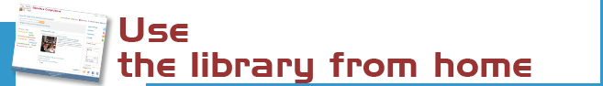
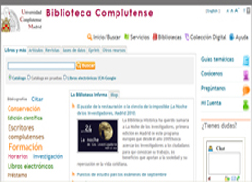 | Our website enables you to:  - Renew and reserve loan books.  - Access online collection (books, journals, theses, databases …).  - Consult a librarian.  - Use guides.  Keep you informed and participate in our Economía Complutense blog.  - Some services require PIN: https://cisne.sim.ucm.es/patroninfo*spi


You can use our online service to find out about availability of your course bibliographies.

The Complutense Library will arrange special opening hours at some libraries during examination periods (Saturdays, Sundays, at night).

The bibliographic and information service can help you in search documents and management bibliographies

The library has rooms for group work

Loan hours: From 9 to 20:30 h.  Deadlines and number of titles:  - Students 8 titles (15 days) and 2 special materials (7 days).  - Researchers and administrative  personnel: 12 titles (30 days) and 4 special materials (7 days).  - Teachers: 25 titles (60 days) and 5 special materials (7 days). | Renewals and reserving.  Reservations and renewals of books in the catalogue may be made using your PIN.Loan conditions:  Reference books (encyclopaedias, dictionaries…), journals, unpublished theses, and works of special value cannot be taken out on loan.  Fines:  Two days for each day overdue.


Our computers are available for study and research.
They are located at:
Reading rooms and catalogs: 50 places
Researchers rooms: 5 computers for researchers. The researches must be accredited by the departments and authorized by the Library.
Wireless Access: 25 laptops for loan inside the library with UCM network connection and the possibility of using personal computers.
Training room: 10 computers


Photocopiers are available for public use. We remind users that maintenance of this machine is the responsibility of the subcontractor


- Support for the use and management of economic information sources.
- Use of virtual campus.
- Support for search and localization of documents.
- Questions and bibliographical alerts.
- Support in the management of bibliographies and citations.
- Indicators for the quality of scientific journals.


If you would like to publish your research online we can help you through our electronic publishing service.

Working with the UCM Publications Service, we will arrange to publish your theses, journal articles, pre-prints and books: ISBN management …
(buc-edicion@buc.ucm.es)

