
We will answer your queries about finding information, carrying out searches, using electronic documents and databases:

In person: At the help desks.
By telephone: 913942964 (school days from 9 to 21).
More information and forms at:
- http://www.ucm.es/BUCM/cps

- http://www.ucm.es/BUCM/necesitoayuda.php

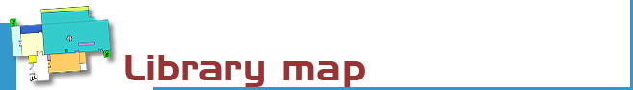

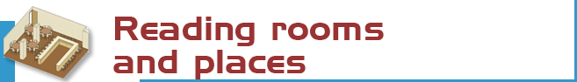
We have 392 reading places distributed as follows:

- Open access room: 202 places
- Reference room: 120 places
- Journals room: 48 places
- Media room and study room: 14 places



The library’s collection is comprised of monographs, serials, statistics, working papers, films, documentaries…, in a variety of formats.

- Journal titles: 1.991
- Books: 177.491
- Special materials (CDs, DVDs…): 3.112

Every item has a catalogue code (signatura) which indicates where the title can be found.
Take for example: D 316.334.3 BOT
- The first letters indicate the collection (In this case D stands for “Depósito”
Stacks)
- The numbers represent the subject (316.334.3
Political sociology),
- The last letters refer to the author (BOT: Bottomore, T.B.)

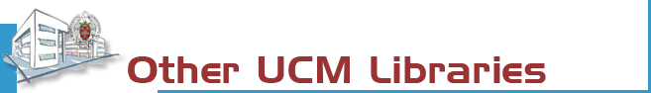
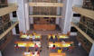 | The Complutense Library is the biggest university library in Spain, with 30 faculty libraries, 9,700 reading places, 3,000,000 of titles, 1,000 computers, and most importantly a staff of 517 people at your service.

 | 

COMPLUTENSE UNIVERSITY OF MADRID

Library

www.ucm.es/bucm/cps

guide | Politics and  Sociology  Sciences

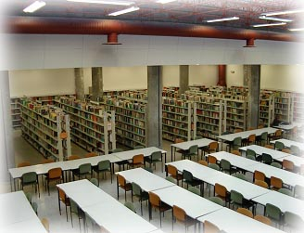
LIBRARY HOURS:  School days: 9 to 21  Special timetables apply during exam periods, Christmas, Easter and in summer, to be announced in advance.  Address:  Campus de Somosaguas s/n  28223 Madrid  Teléphone:  - Library Information: 913942967  - Loans: 913942964  - Inter-library loans: 913942762  - Technical procedure: 913942967  - Librarian: 913942869  - Sub-librarian: 913942968  Fax: 91-3942968 ; 913942762  E-mail::  buc_cps@buc.ucm.es | Transport:  E.M.T. BUSES  Line A: Moncloa – Campus de Somosaguas  Line H: Aluche – Campus de Somosaguas  Line I. Somosaguas – Campus de Moncloa  TRANSPORT CONSORTIUM CAM  (Llorente Company) 561A y 563 Aluche-Pozuelo (stop in the Húmera-Pozuelo road)  METRO LIGERO (LINEA 2)  Aravaca-Colonia Jardín Station  Train stop Campus de Somosaguas

More information and forms available at the help desks
and on our website: www.ucm.es/bucm/cps

September 2010


Who. All members of our university community may use all our services, take out books on loan and access our online collections off campus. Members of the UCM Alumni Association and Friends of the UCM have access to some of our services such as home loan.
Our materials can be used by everybody in the reading rooms (restrictions may be in force during examination periods). Visitors who wish to use other services or borrow books must be recognised by a professor or by the Director of the Library by means of a valid library card, which is personal and non-transferable. For some services a PIN number is required.
Improper use of materials or inappropriate behaviour towards our staff or other users constitutes gross misconduct and will be dealt with by academic or legal authorities (Library Rules).
More information and forms available at the help desks


The library organizes occasional guided tours and by prior arrangement to further awareness of its services.

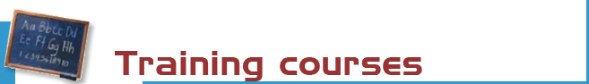

The library organizes free training courses on the use of its resources:
- General
- Advanced
- Taylor made courses on demand

More information regarding membership, etc. can be found at the help desks and at our website



The holdings are divided into two main collections:

- Free Access Collection: Basic bibliography, handbooks and manuals (L), Statistics (E), Reference books (R), working papers (W), films, documentaries (V), Journals (alphabetic order).

- Book Stacks Collection: 19th century books (A), Gómez Arboleya Collection (GA), books published before 1958 (DP), books published after 1958 (D y N), Journals (PP), videos and DVDs (ME), CDS (CD). To consult these materials it is required to fill out a request form at the help desk.



Purchase requests. Please let us know which titles we should acquire to complement our catalogue, or which titles need more copies.

Complaints or suggestions. You may complain or make suggestions in person, or by e-mail. We will contact you as soon as possible.



We are making every effort to ensure that our premises are adapted to the needs of disabled persons. JAWS and MAGIC software is available for sight-impaired users. More info at buc-discapacidad@buc.ucm.es
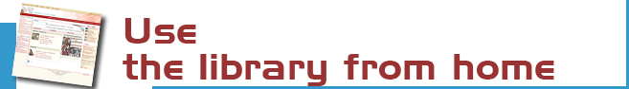
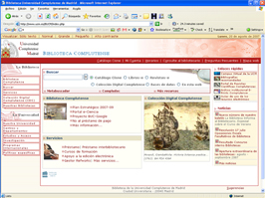  Our website enables you to:  - Renew and reserve loan books.  - Access our online collection  (over 50.000 books, 40.000 journal titles, theses, databases...). | - Consult a librarian via Chat Service  - Request general or specialized information about a topic or about how to use the electronic resources (databases…) via formularios.  - Browse the web resources selected by the library (Complured, Delicious).  - Keep informed and participate in our blog, Facebook, Tuenti, Twitter.  -Self-training: there are a number of guides and tutorials to help you with the use of the library resources  Some servieces require PIN.


Our website enables you to:
- Find out about availability of your course bibliographies.
- Search the Subject Guides to get all the information about a topic

The Complutense Library will arrange special opening hours at some libraries during examination periods (Saturdays, Sundays, at night).

Loan conditions:  Reference books (encyclopaedias …), journals, unpublished theses, and works of special value cannot be taken out on loan.  Fines:  Two days for each day overdue.  Library Hours: from 9 a 20:45 h. | Deadlines and number of titles:  - Students: 8 titles (15 days). 2DVD (1 week)  - Researchers and administrative  personnel: 12 titles (1 month)  - Teachers: 25 titles (2 months)  Renewals and reserving.  Reservations and renewals of books in the catalogue may be made using your PIN.


OPAC’S: 12 computers intended for searching the catalogue
15 Computers to access the Internet
MEDIATECA. 2 TV, 2 Videos, 2 DVD
51 LAPTOPS to use at the library premises
54 NETBOOKS on loan for 12 hours period (library opening hours)
WIFI Internet access through the UCM network



A photocopier is available for public use. We remind users that maintenance of this machine is the responsibility of the subcontractor.
1 scanner


The bibliography service can help you find referenced books and documents.
Stay up to date by subscribing to the e-mail summary and new additions service.


We can obtain documents from other national and international libraries which are not in our collections. (Just for teachers and Researchers)



If you would like to publish your research online we can help you through our electronic publishing service.
Working with the UCM Publications Service, we will arrange to publish your theses, journal articles, pre-prints and books: ISBN management …
(buc-edición@buc.ucm.es)

