
We will answer your queries about finding information, carrying out searches, using electronic documents and databases:
In person: At the help desks.
By telephone: 913942731
E-mail: buctrs@buc.ucm.es
More information and forms at: www.ucm.es/bucm/trs
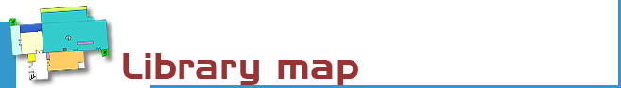

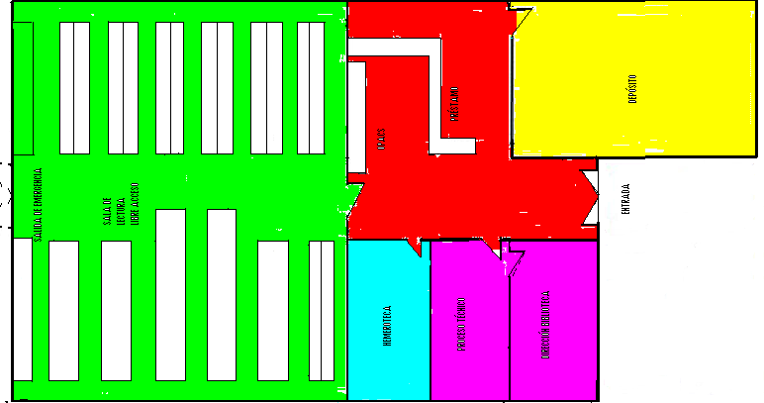

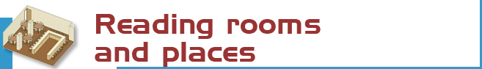
Reading rooms and places
We have 78 reading places distributed as follows:
Reading room (open access): 78 places
Journals room: 10 places


• Monographs: 36.622 items.  • Journals: 593 titles.  • Video y DVD: 2.144 items.  • CD-ROM: 637 items.  ● Tests: 58 items | The catalogue code indicates where the title can be found.  For example, P 364.22ALI  - The first letters indicate the collection  (in this case P stands for open access  monographs)  - the numbers show the subject  (364.22: Poverty)  - and the last letters represent the author  (ALI: Aliena, Rafael).

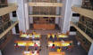 | The Complutense Library is the biggest university library in Spain, with 30 faculty libraries, 10,000 reading places, 2.856,000 titles, 1,200 computers, and most importantly a staff of 500 people at your service.




COMPLUTENSE UNIVERSITY OF MADRID Library

www.ucm.es/bucm/eis

guide | Social Work

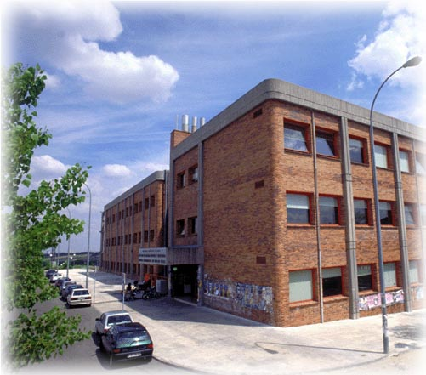
LIBRARY HOURS:  School days: 09:00 to 21:00  Special timetables apply during Christmas, Easter and in summer, to be announced in advance.  Address:  Edificio Interfacultativo  Campus de Somosaguas  28223 Pozuelo de Alarcón (Madrid)  Tel:  • Library Information: 913942731  • Loans: 913942731  • Inter-library loans: 913942731  • Technical procedure: 913942731  • Sub-directorate: 913942731  • Directorate: 913942726  Fax: 91-3942743  E-mail: buc_trs@buc.ucm.es | Transport  METRO LIGERO  - Line 2: Campus de Somosaguas.  E.M.T. BUSES  - Lines A (Moncloa-Somosaguas), B (Aravaca-Somosaguas), I Ciudad Universitaria-Somosaguas, H (Aluche-Somosaguas)

More information and forms available at the help desks
and on our website: www.ucm.es/bucm/trs

October 2012



Who. All members of our university community may use all our services, take out books on loan and access our online collections off campus. Members of the UCM Alumni Association and Friends of the UCM (http://www.ucm.es/info/antiguosucm) have access to some of our services such as home loan.

Our materials can be used by everybody in the reading rooms (restrictions may be in force during examination periods). Visitors who wish to use other services or borrow books must be recognised by a professor or by the Director of the Library by means of a valid library card, which is personal and non-transferable. For some services a PIN number is required.

Improper use of materials or inappropriate behaviour towards our staff or other users constitutes gross misconduct and will be dealt with by academic or legal authorities (Library Rules).



The library organizes occasional guided tours and by prior arrangement to further awareness of its services.

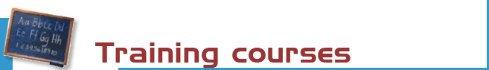

The library organizes free courses on the use of its online resources.
More information regarding membership, etc. can be found at the help desks and at buc_trs@buc.ucm.es

Courses:
- Use of catalogues, databases and online journals.
- Advanced use of information resources for research in social work, social services or social policy.



Books: the most recent and in-demand titles can be found in the open access room (codes P and R). Other titles are in the deposit (code D). Please request these at the loan counter.

Journals (code H): the latest numbers are available on the journal display shelves on the Journals room. Earlier copies can be found on the Deposit and should be requested at the loan counter.

CDR, CDA, DVD and other materials: (codes V, CDR, CDA and DVD) can be requested at the loan counter.



Purchase requests. Please let us know which titles we should acquire to complement our catalogue, or which titles need more copies. Can you do it by printed formal at the loan counter or by electronic formal from home.

Complaints or suggestions. You may complain or make suggestions in person, or by e-mail. We will contact you as soon as possible.



We are making every effort to ensure that our premises are adapted to the needs of disabled persons. JAWS and MAGIC software is available for sight-impaired users. More info at buc-discapacidad@buc.ucm.es
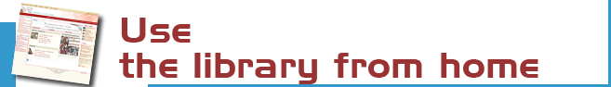

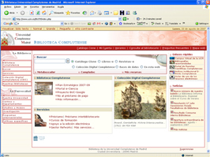 | Our website enables you to:  - Renew and reserve loan books.  - Access our online collection (books, journals, theses, databases …).  - Consult a librarian.  - Use guides.  - And much more ...  Some services require library card and PIN.


You can use our online service to find out about availability of your course bibliographies.

The Complutense Library will arrange special opening hours at some libraries during examination periods (Saturdays, Sundays, at night).


Loan conditions:  Reference books (encyclopaedias …), journals, unpublished theses, and works of special value cannot be taken out on loan.  Fines:  One day for each day overdue.  Library hours: From 09:00 to 20:30. | Deadlines and number of titles:  - Students: 8 titles (15 days).  - Researchers and administrative  personnel: 12 titles (30 days).  - Teachers: 25 titles (60 days).  Renewals and reserving.  Reservations and renewals of books in the catalogue may be made using the library card and PIN.



Our computers are available for public use to access the Internet, search our online collections. The library offers Wifi Internet access through the UCM network.
10 laptops are available for use in the wifi areas at the building.
Library hours: from 10:00 to 20:00.



2 photocopier are available for public use. We remind users that maintenance of this machine is the responsibility of the subcontractor.



The bibliography service can help you find referenced books and documents.
Stay up to date by subscribing to the e-mail summary and new additions service.



We can obtain documents from other national and international libraries which are not in our collections (only for researchers and teachers)



If you would like to publish your research online we can help you through our electronic publishing service.
Working with the UCM Publications Service, we will arrange to publish your theses, journal articles, pre-prints and books: ISBN management …
(buc-edicion@buc.ucm.es)

