

We will answer your queries about finding information, carrying out searches, using electronic documents and databases:
In person: At the help desks.
By telephone: 913941781 (school days from 9 to 21).
More information and forms at: www.ucm.es/bucm/far

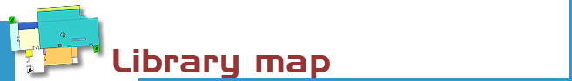

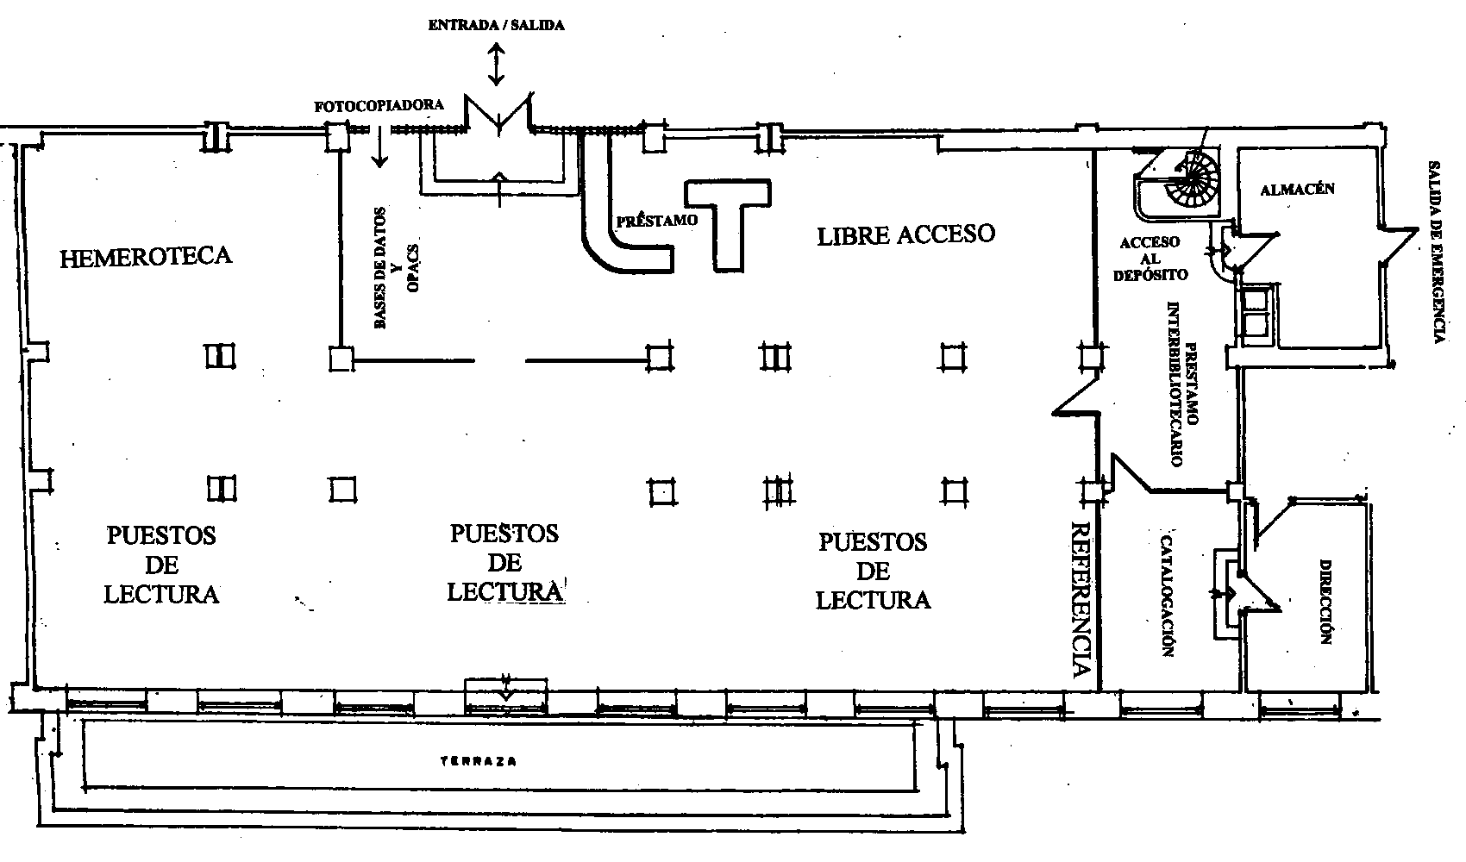

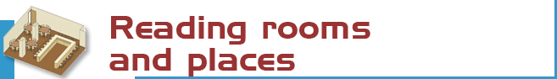
Reading rooms and places

We have 206 reading places


 | The catalogue code indicates where the title can be found.  For example, L 615.011 AVE  - The first letters indicate the collection  (in this case L stands for open access  monographs)  - the numbers show the subject  (615.011: Pharmaceutical Chemistry)  - and the last letters represent the author  (AVE: Avendaño, Carmen).
  Open Access Collection: 5.463
  Catalogue codes:
  - L – Books
  - LF – Booklets
  - R – Reference
  - BT – Librarians’ resource materials
  - CD - Special materials
  - O – Movies
  - L82 - Novels
  Bookstack Collection : 60.807
  Catalogue codes :
  - D – Books
  - DF – Booklets
  - TD, TM - Theses
  Serials : 3.679
  Catalogue code : PP
  19th Century : 5. 314
  Catalogue code: A

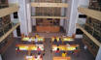 | The Complutense Library is the biggest university library in Spain, with 30 faculty libraries, 9,700 reading places, 3,000,000 of titles, 1,000 computers, and most importantly a staff of 517 people at your service.




COMPLUTENSE UNIVERSITY OF MADRID Library

www.ucm.es/bucm/far

guide | Pharmacy

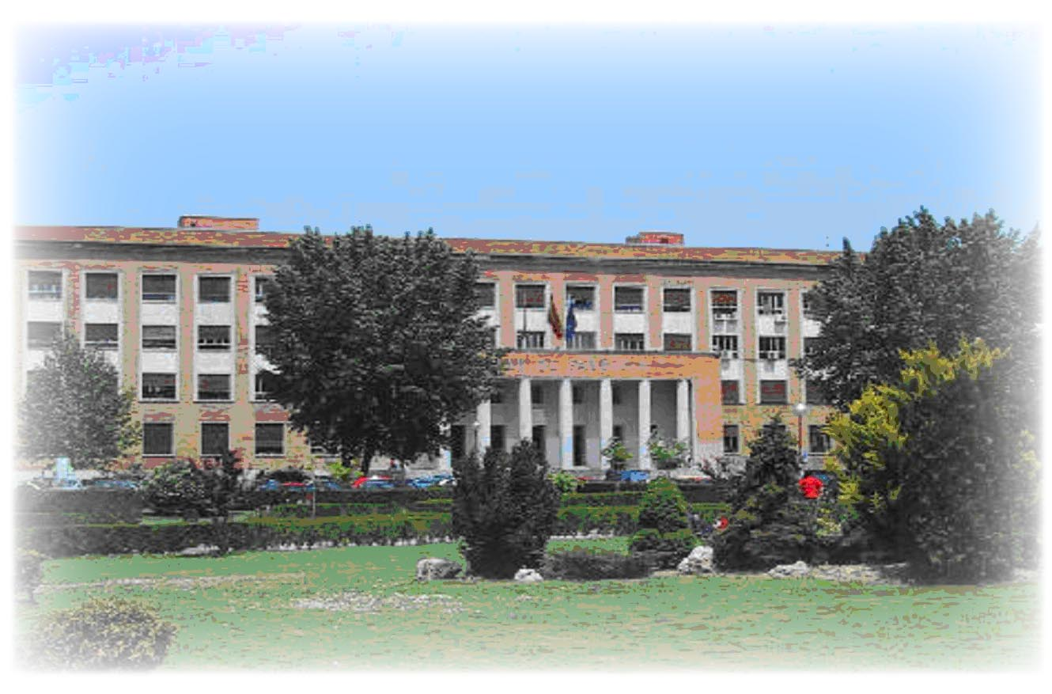
LIBRARY OPENING HOURS:  School days:9 to 21  - Monday to Thursday: 9-21  - Friday 9 to 20:45  Special timetables apply during exam periods, Christmas, Easter and in summer, to be announced in advance.  Address:  C/Plaza de Ramón y Cajal s/n  2nd floor  Ciudad Universitaria  28040 Madrid  Tel:  • Library Information: 913941781  • Loans: 913941781  • Inter-library loans: 913941781  • Technical procedure: 913942093  • Library Director: 913941780 | Fax: 91-3941781  E-mail: buc_far@buc.ucm.es  Transport  METRO  - Line 6: Ciudad Universitaria.  E.M.T. BUSES  - Lines G, U, I, 82, 83 and 132

More information and forms available at the help desks
and on our website: www.ucm.es/bucm/far, Facebook and ParacetaBlog.

September 2012



Who. All members of our university community may use all our services and borrow books by means of a valid library card which is personal and non-transferable. For access to our online collections off campus a PIN number is required. Members of the UCM Alumni Association and Friends of the UCM have access to some of our services such as home loan.

Our materials can be used by everybody in the reading rooms (restrictions may be in force during examination periods). Visitors who wish to use other services or borrow books must be introduced by a professor or by the Library Director.

Improper use of materials or inappropriate behaviour towards our staff or other users constitutes gross misconduct and will be dealt with by academic or legal authorities (Library Rules).



The library organizes guided tours by prior arrangement.

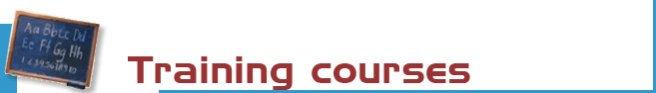

The library organizes free courses on the use of its online resources.
More information regarding membership, etc. can be found at the help desks and at buc_far@buc.ucm.es

Our website offers guides for using our resources.



Books: the most recent and in-demand titles can be found in the open access room (codes L, LF, and R). Earlier titles are in the bookstack (code D and DF). Please request these at the loan counter.

Journals (code PP): the latest numbers are available on the journal display shelves. Earlier copies can be found on the stack and should be requested at the loan counter.

CD-ROM, DVD y other materials: (code CD) can be found in the open access room.

For other materials please consult: www.ucm.es/bucm/far



Purchase requests. Please let us know which titles we may acquire to complete our collection or which titles need more copies.

Complaints or suggestions. You may complain or make suggestions in person, or by e-mail. We will contact you as soon as possible.



We are making every effort to ensure that our premises are adapted to the needs of disabled persons. JAWS and MAGIC software is available for sight-impaired users. More info at buc-discapacidad@buc.ucm.es
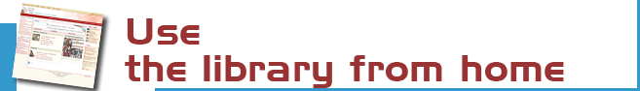

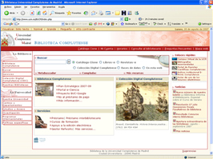 | Our website enables you to:  - Renew and reserve books from certain collections.  - Access our online collection (books, journals, theses, databases …).  - Consult a librarian.  - Use guides.  - To keep informed and participate via our blogs.  - And much more ...  Some services require PIN.


You can check the availability of your course bibliographies through our Web.

The Complutense Library will arrange special opening hours at some libraries during examination periods (Saturdays, Sundays, at night).


Loan conditions:  Reference books (encyclopaedias …), journals, unpublished theses, and works of special value cannot be taken out on loan.  Fines:  Two days for each day overdue.  Library Opening Hours: From 9 to 21. | Deadlines and number of titles:  - Students: 4 titles from Pharmacy Library and 4 titles from other librarians (7 days).  - Researchers and administrative  personnel: 20 (1 month).  - Teachers: 35 (2 months)  Renewals and reserving.  Reservations and renewals of books in the catalogue may be made using your PIN.



Our computers are available for public use to access the Internet and search our online collections. The library offers Wifi Internet access through the UCM network.
Library Hours: from 9 to 20.30



A photocopier is available for public use. We remind users that maintenance of this machine is not responsibility of the Library.



The Information Service helps you find documents and books of your interest.



We can obtain documents from other national and international libraries which are not in our collections.



If you would like to publish your research online we can help you through our electronic publishing service.
Working with the UCM Publications Service, we will arrange to publish your theses, journal articles, pre-prints and books: ISBN management …
(buc-edicion@buc.ucm.es)

