

We will answer your queries about finding information, carrying out searches, using electronic documents and databases:
In person: At the help desks.
By telephone: 913941781 (school days from 9 to 21).
More information and forms at: www.ucm.es/bucm/opt

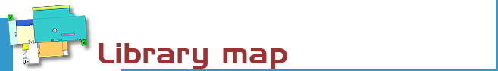

guideeeeeeeee deea | Optics

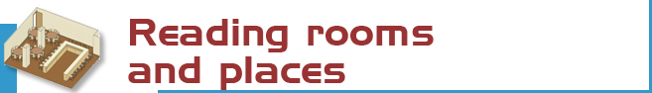

We have 222 reading places distributed in the following way:  - Free access: 132 places.  - Hemeroteca, Mediateca: 32 places.  - Working groups rooms: 30 places  - Researchs room: 24 places | 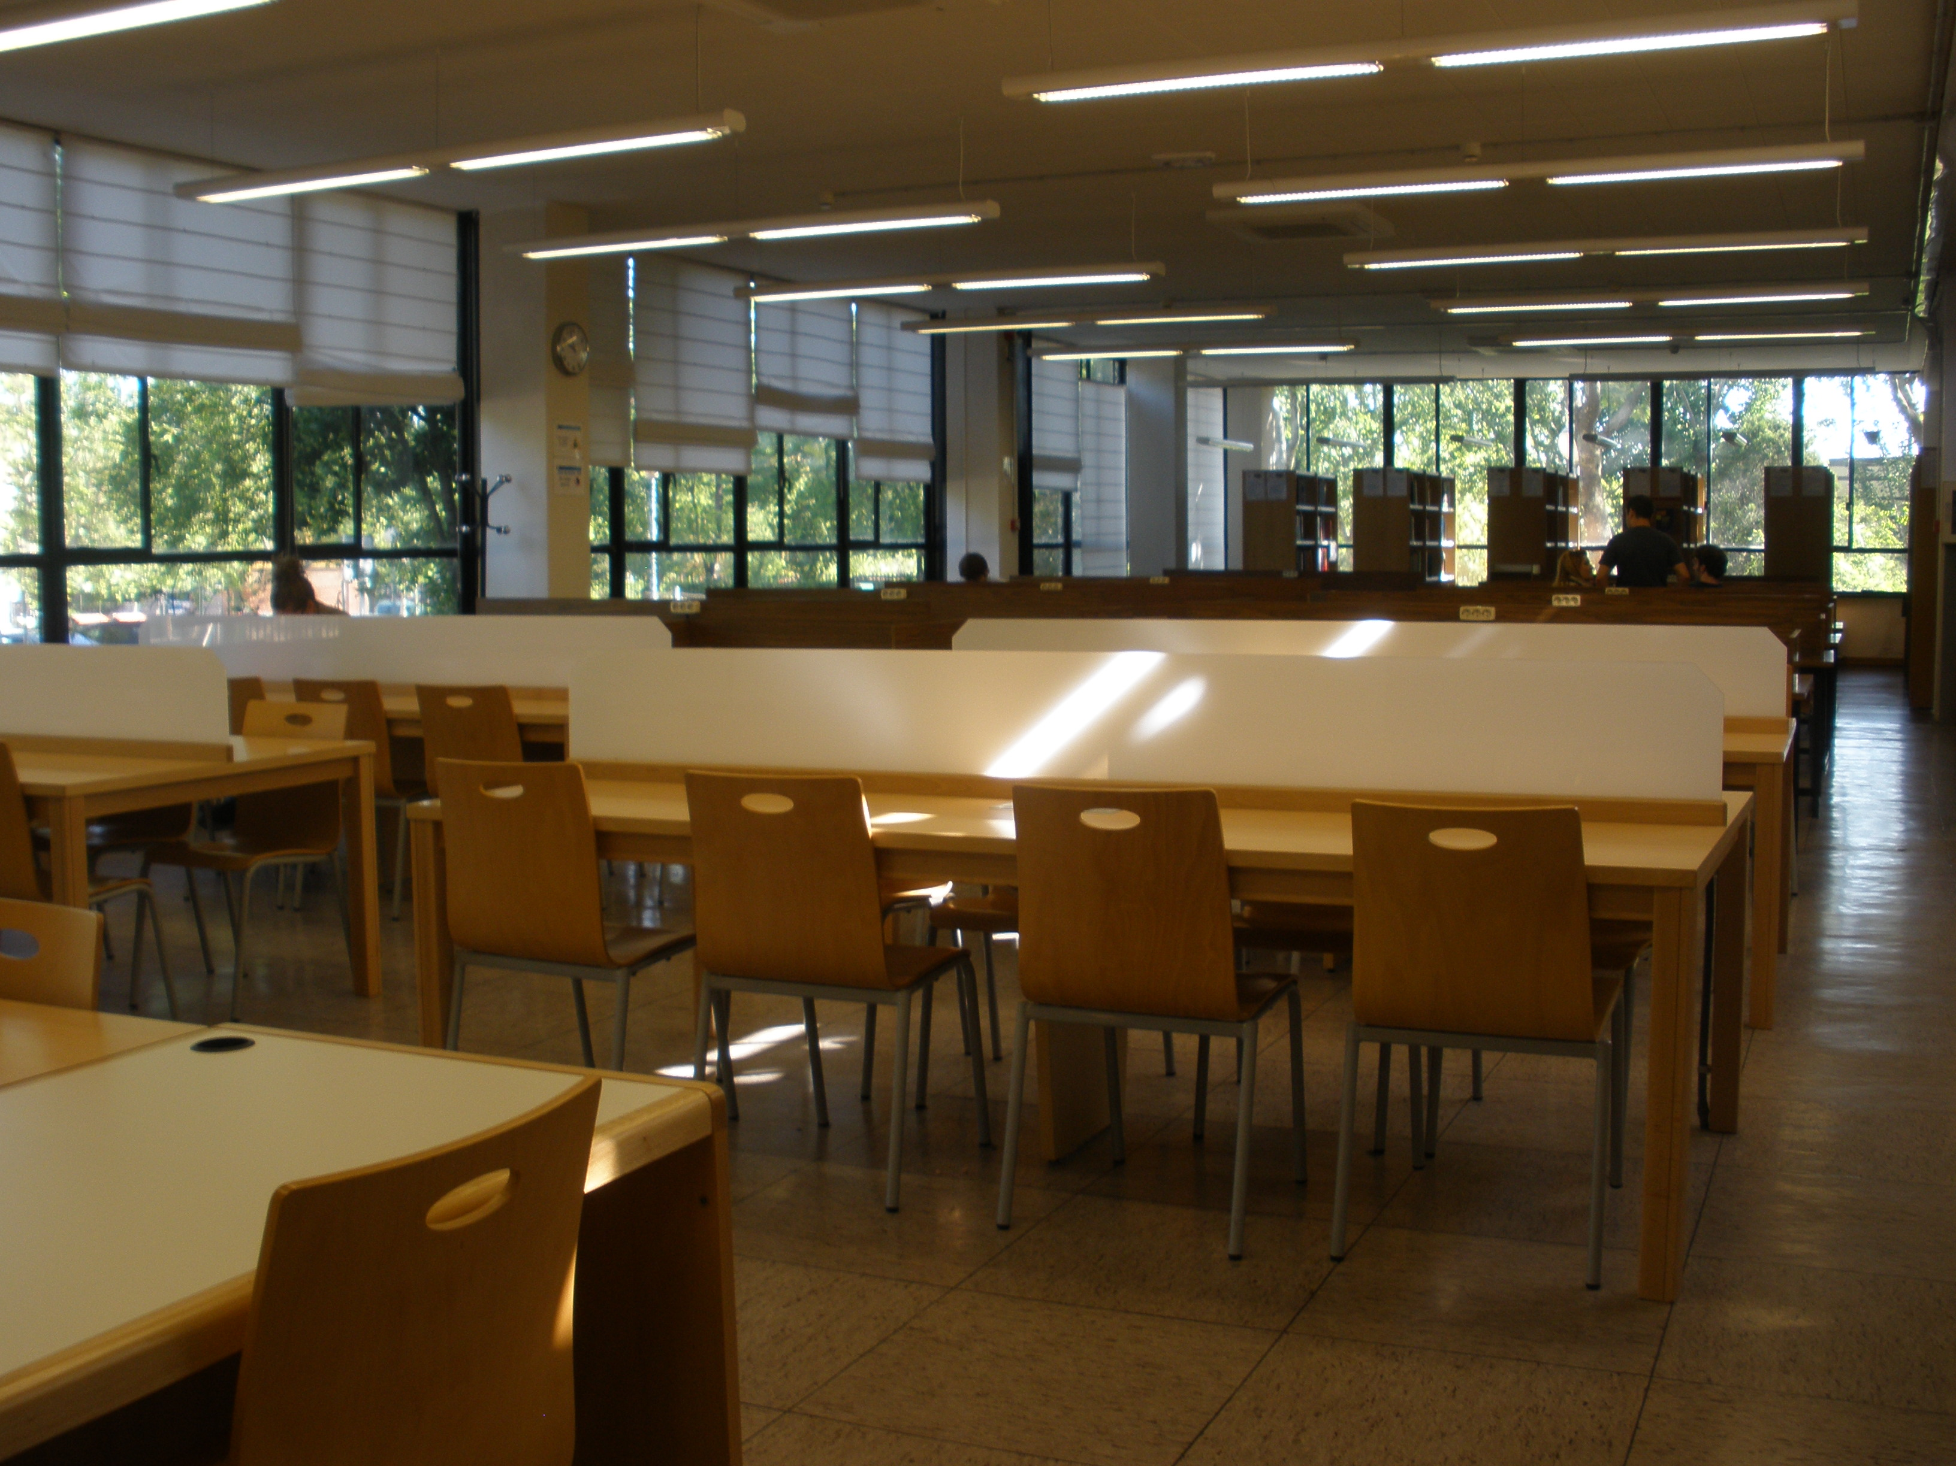



- Books: 9.800  - Serials: 133  - CDs: 466  - Films: 264  - DVDS: 42  - Special materials: 8.100  - 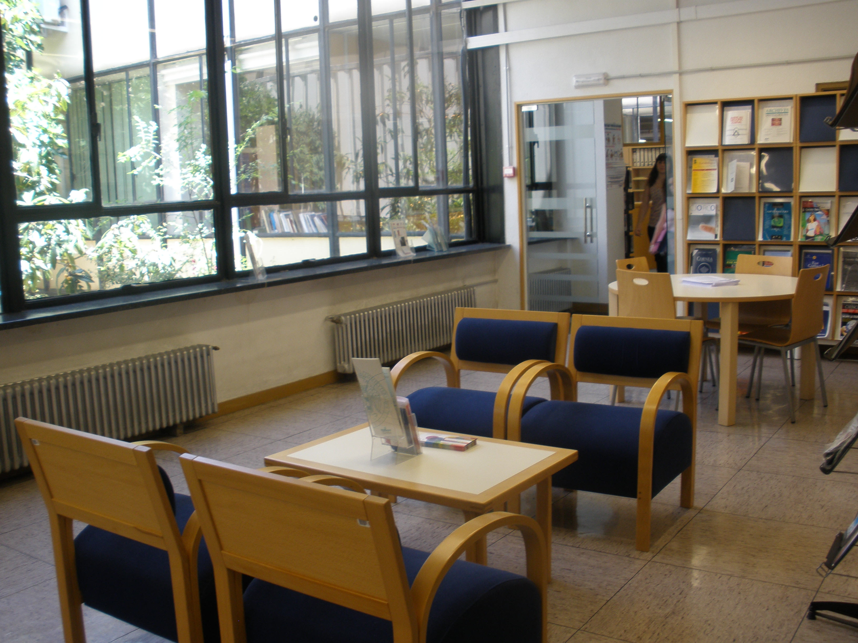 | The catalogue code indicates where the title can be found. For Example:  LA 612.84 AGU  - The first letters indicate the collection (in this case LA stand for open access),  - the numbers show the subject (612.84: Ocular physiology),  - and the last letters represent the author AGU (Aguilar, Mariano).


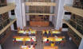 | The Complutense Library is the biggest university library in Spain, with 30 faculty libraries, 10,000 reading places, 3,000,000 titles, 1,200 computers, and most importantly a staff of 540 people at your service.


COMPLUTENSE UNIVERSITY OF MADRID

Library

www.ucm.es/bucm/opt

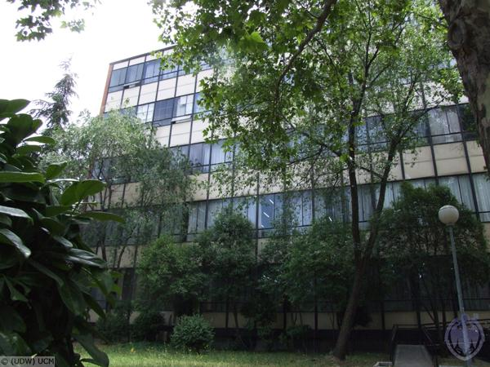
Library hours  School days:: 9 a 21 h.  Special timetables apply during exam periods, Christmas, Easter and in summer, to be announced in advance.  Address:  C/Arcos de Jalón, n 118  28037 Madrid  Tel.:  - Library information: 913946870  - Interlibrary loans: 913946870  - Technical procedure: 913946870  - Library Director: 913946896  Fax: 913946885 (general)  e-mail: buc_opt@buc.ucm.es | Transport:  METRO  - Line 7: San Blas.  E.M.T. BUSES  - Line 4  Ciudad Lineal-Vicálvaro  -Line 48  Manuel Becerra-Canillejas

More information and forms available at the help desks
and on our website: www.ucm.es/bucm/opt

September 2010


Who. All members of our university community may use all our services and borrow books by means of a valid library card which is personal and non-transferable. For access to our online collections off campus a PIN number is required. Members of the UCM Alumni Association and Friends of the UCM have access to some of our services such as home loan.

Our materials can be used by everybody in the reading rooms (restrictions may be in force during examination periods). Visitors who wish to use other services or borrow books must be introduced by a professor or by the Library Director.

Improper use of materials or inappropriate behaviour towards our staff or other users constitutes gross misconduct and will be dealt with by academic or legal authorities (Library Rules).



The library organizes ocasional guided tours by prior arrangement

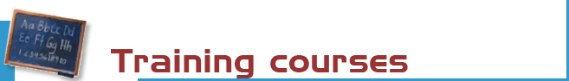

The library organizes free courses on the use of its online resources.
More information regarding membership, etc. can be found at the help desks and at buc_opt@buc.ucm.es

Courses:
- Library: organization, use of catalogues, databases and online journals.
- Introduction use of information resources for research in óptics and optometry and related sciences.

Our website offers guides for using our resources



Books: the most recent and in-demand titles can be found in the open access room (scodes R, LA). Earliner titles are in the bookstack (code D), please request these at circulation desk.

Journals (code PP): the latest numbers are available on the hemeroteca. Earlier copies can be found on restricted access shelves and should be request at the circulation desk.

CD-Rom, DVD and other materials: : (codes V, I, O): can be requested at the circulation desk.

For other materials please consult: www.ucm.es/bucm/opt



Purchase requests. Please let us know which titles we may acquire to complete our collection or which titles need more copies.

Complains or suggestions. You may complain or make suggestions in person, or by e-mail. We will contact you as soon as possible.



We are making every effort to ensure that our premises are adapted to the needs of disabled persons. JAWS and MAGIC software is available for sight-impaired users. More info at buc-discapacidad@buc.ucm.es

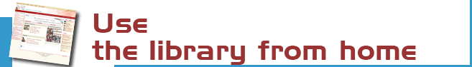
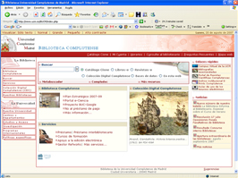 | Our website enables you to:  - Renew and reserve loan books.  - Access our online collection (books, journals, theses, databases …).  - Consult a librarian.  - Use guides.  - And much more ...  Some services require PIN


You can use our online service to find out about availability of your course bibliographies.

The Complutense Library will arrange special opening hours at some libraries during examination periods (Saturdays, Sundays, at night).



Loan conditions:  Reference books (encyclopaedias …), journals, unpublished theses, and works of special value cannot be taken out on loan.  Fines:  Two days for each day overdue.  Library Opening Hours Monday to Friday , 9 a 21 h. | Deadlines and number of titles:  - Students: 8 titles (7 days).  - Researchers and administrative  personnel: 12 (15 days)  - Teachers: 25 (2 months)  Renewals and reserving.  Reservations and renewals of books in the catalogue may be made using your PIN.


Our computers are available for public use to access the Internet and search our online collections. 6 laptops are also available. The library offers Wi-Fi Internet access through the UCM network.

Library hours: 9 to 20,30



A photocopier is available for public use. We remind users that maintenance of this machine is not responsibility of the Library.



The Bibliography service can help you find referenced books and dpcuments. Stay up to date by subscribing to the e-mail summary and new additions service.



We can obtain documents from other national and international libraries which are not in our collections.

Contact with bucpiopt@buc.ucm.es



If you would like to publish your research online we can help you through our electronic publishing service.
Working with the UCM Publications Service, we will arrange to publish your theses, journal articles, pre-prints and books: ISBN management …
(buc-edición@buc.ucm.es)

