
We will gladly answer your queries regarding finding bibliographic resources, carrying out searches, using electronic documents and databases:
In person queries: At our circulation desk.
By telephone: 913944644 (school days from 08.30 to 20.30).
More information and forms at:
- www.ucm.es/bucm/fis
- www.ucm.es/BUCM/necesitoayuda.php

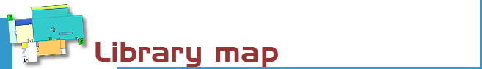
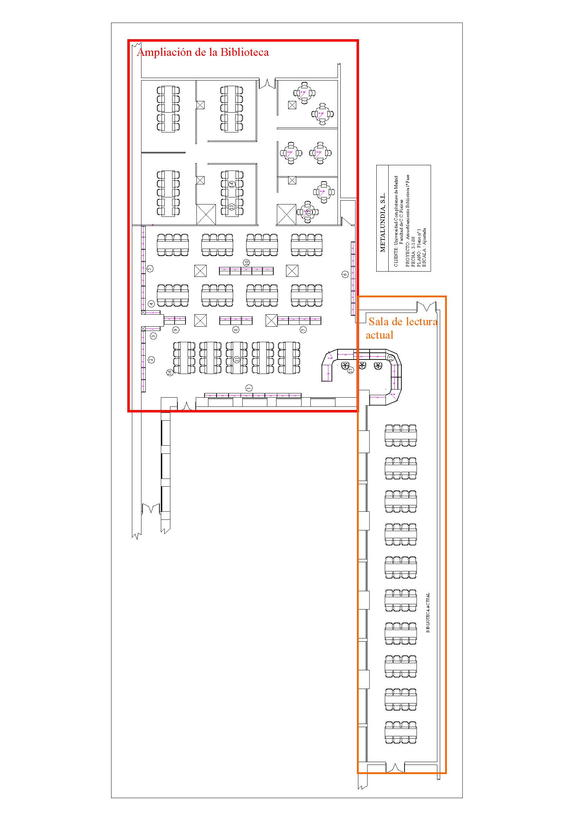

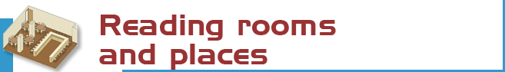
Reading rooms and other research locations
We have 101 desks distributed as follows:
GROUND FLOOR: Loans
- Reading: 92 reading desks
1st FLOOR:
- Media room: 8 computer workstations
- Scholarly journals, reference and reading room: 1 reading desks


• Free access to monographs (catalogue code F): 8927 items. *  • Journals (H): 1191 titles. *  • Reference books (R): 601 items.  • Rarely used (J): 2942 items.  • Special collections (Science Fiction, Movies, etc.) (O-N-V-DVD) 259 items.  • Rare and old items collection (A): 4474 items.*  • Theses and dissertations (T): 2.629 items.*  Additionally there are another 15000 items located at departmental libraries.  *This collections are, momentarily, not in use because of some building work. | The catalogue code indicates where the title can be found.  For example, F537.8PUR  - One or more letters on the right margin of the code indicate the collection to which the item belongs  (e.g. in this case F stands for open access  monographs)  - the numbers show the subject  (e.g. 537.8: indicates "Computational Databases")  - Letters on the left margin represent the author  (PUR: Purcell, Edward M.).

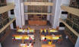 | The Complutense Library is the biggest university library in Spain, with 30 faculty libraries, 9,700 reading places, 3,000,000 titles, 1,000 computers, and most importantly a staff of 467 people at your service.




COMPLUTENSE UNIVERSITY OF MADRID Library

www.ucm.es/bucm/fis

guide | Physics

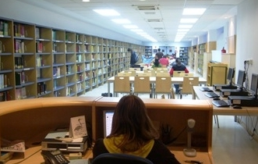
LIbrary hours:  School days: 08.30 to 20.30.  Special variable timetables apply during exam periods, Christmas, Easter and in summer recess periods, to be announced in advance.  Address:  Facultad de Ciencias Físicas  Ciudad Universitaria  28040 Madrid  Tel:  • Library Information: 913944644  • Loans: 913944651  • Inter-library loans: 913944644  • Administrative offices: 913944644  • Second library manager: 913944763  • Library Director: 913944470  Fax: 91-3947524  E-mail: buc_fis@buc.ucm.es | Transportation  UNDERGROUND  - Route 6: Ciudad Universitaria.  BUSES E.M.T.  - Route F: Cuatro Caminos - Filosofía B. (continue until end of route).  - Route G: Moncloa - Filosofía B.  - Route I: Somosaguas – Campus de Moncloa  - Route U  - Route 82 y 132

More information and forms available at the help desks
and on our website: www.ucm.es/bucm/fis

September 2011



Who. All members of our university community may have access to all of our services, including borrowing books and accessing our online collections off campus. Members of the UCM Alumni Association and Friends of the UCM have access to some of our services such as home loan.

Our materials can be used by all patrons in reading rooms (restrictions may apply during examination periods). Visitors who wish to use services including borrowing books must be recognised by a professor to obtain from the Director of the Library a valid library card, which is personal and non-transferable. For some services a PIN number is required.

Improper use of materials or inappropriate behaviour towards our staff or other users constitutes gross misconduct and will be dealt with by academic or legal authorities (Library Rules).



The library offers library tours regularly scheduled and by prior appointment.

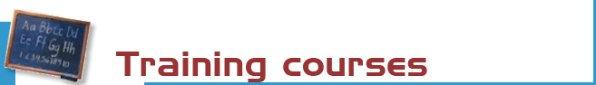

The library organizes free and customized workshops on the use of its online resources.
Further information regarding eligibility of attendance, etc. can be found at the help desks and at buc_fis@buc.ucm.es

Courses:
- Use of catalogues, databases and online journals.
- Advanced use of information resources for research in information technology and related sciences.

Online support:
Find guides for using our resources on our website.



Books: the most recent and in-demand titles can be found in the open access rooms (on the ground floor). Earlier titles are located in the deposit (code D) or display cabinets (code V). Please request these at the loan counter. There is also an open access science fiction collection (code N on the 1st floor).

Journals (code P): the latest numbers are available on the journal display shelves on the 3rd and 1st floors. Earlier copies can be found on restricted access shelves and should be requested at the loan counter.

CD-ROM, DVD y other materials: (codes CD, DV, DQ, VI, CDP, T, TC and F) can be requested on the 1st floor counter.

For other materials, please check out our website: www.ucm.es/bucm/fis



Purchase requests. Please make your suggestions for the acquisition of new titles to enrich our collections.

Complaints or suggestions. You may report issues and make suggestions in person, or by e-mail. We will contact you as soon as possible.



We are making every effort to ensure that our premises are adapted to the needs of disabled persons. Software packages such as JAWS and MAGIC are available for sight-impaired patrons. More info at buc-discapacidad@buc.ucm.es
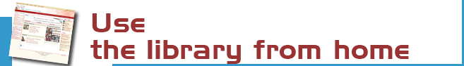

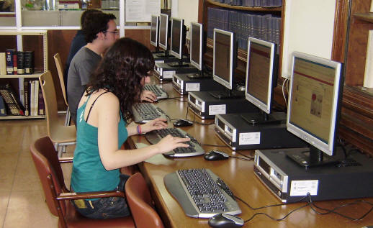 | Our website enables you to:  - Renew and reserve loan books.  - Access our online collection (books, journals, theses, databases …).  - Consult a librarian.  - Use guides.  - To keep informed and participate via our blog: Accionirreacción  - And much more ...  Some services require PIN.


You can use our online service to find out about availability of your course bibliographies.

The Complutense Library will arrange special opening hours at some libraries during examination periods (Saturdays, Sundays, at night).


Loan conditions:  Reference books (encyclopaedias …), journals, unpublished theses, and works of special value cannot be checked out on loan.  Penalties:  Two-day loss of privileges for each day overdue.  Library Hours: From 9:00 to 20:45. | Deadlines and number of titles:  - Students: 12 titles (15 days).  - Researchers and UCM administrative staff: 20 (1 month).  - UCM faculty: 35 (2 months)  Renewals and reserving.  Reservations and renewals of books in the catalogue may be made using your PIN.  Renewals of books in Spanish are excluded)



Our computers are available for public use to Internet access and search our online collections. The library offers Wifi Internet access through the UCM network.
Library Hours: from 8.30 to 21.00



Photocopy machines are available for public use. We remind patrons that maintenance of this machine is the responsibility of the subcontractor.



Staff at our Information Desks will help you find referenced books and documents.
Stay up to date by subscribing to the e-mail summary and new additions service.



We can obtain documents from other national and international libraries not currently available in our collections.



If you would like to publish your research online, we can help you through our electronic publishing service. As part of a joint service with the UCM Publications Service, we will arrange to publish your theses, journal articles, pre-prints and books: ISBN management …
(buc-edición@buc.ucm.es)

