
We will answer your queries about finding information, carrying out searches, using electronic documents and databases:
In person: At the help desks.
By telephone: 913947523 (school days from 09:00 to 21:00).
More information and forms at:
- http://www.ucm.es/BUCM/eis
- http://www.ucm.es/BUCM/necesitoayuda.php
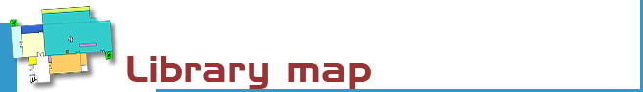
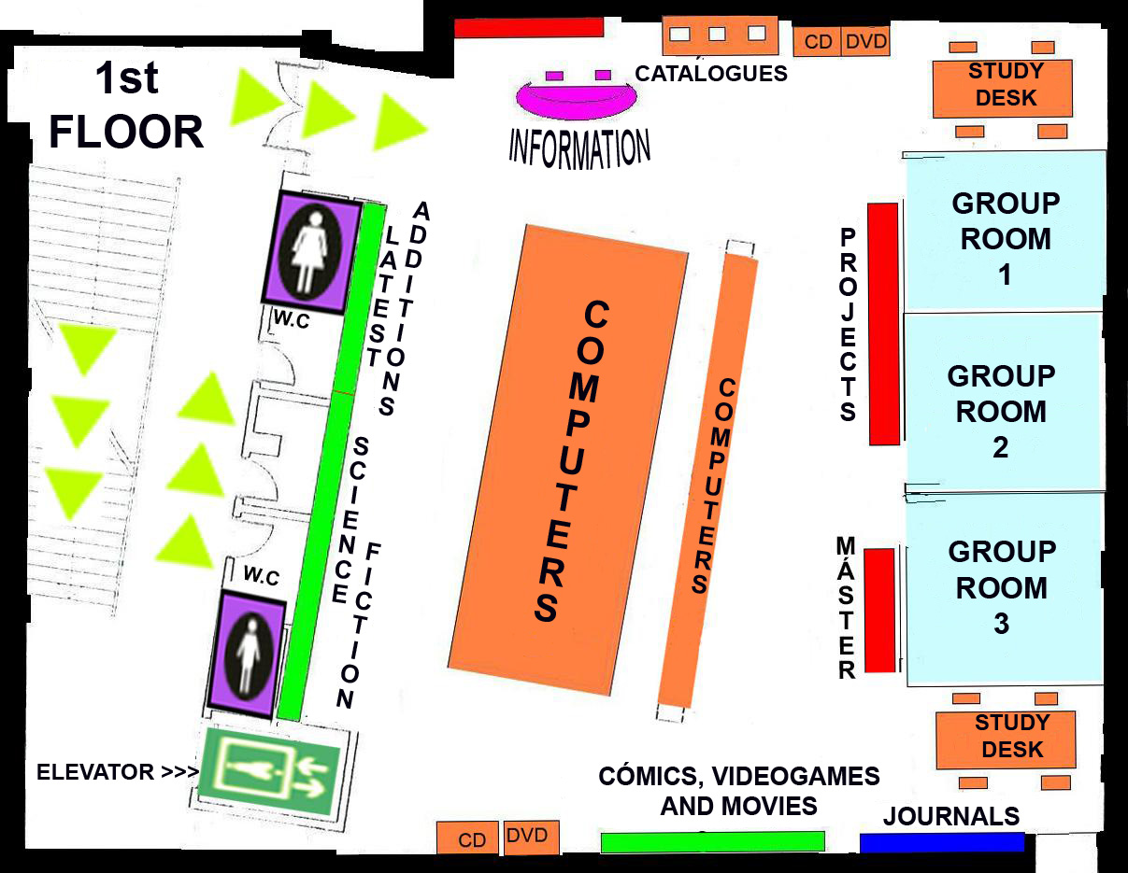
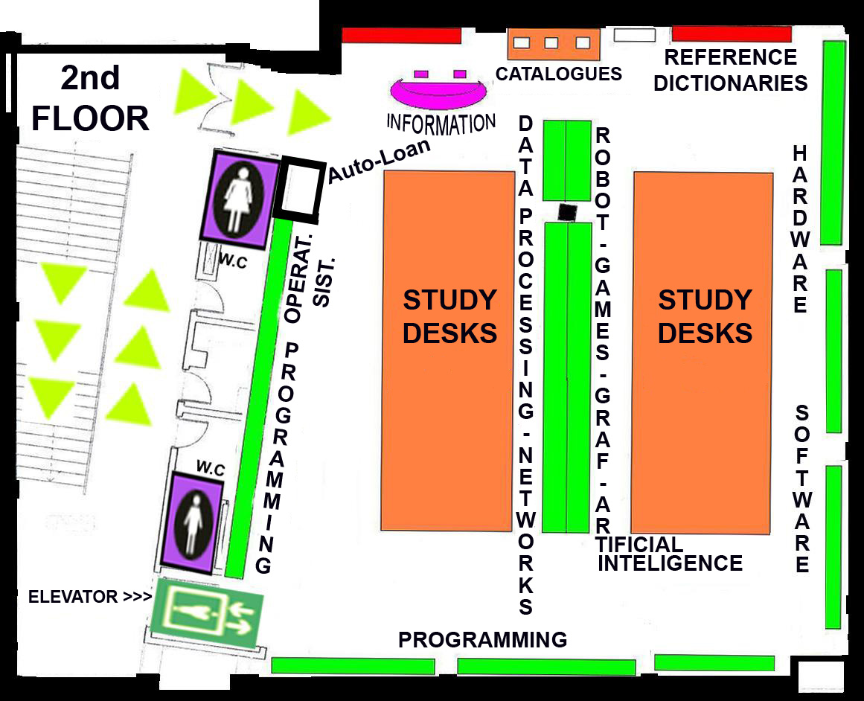
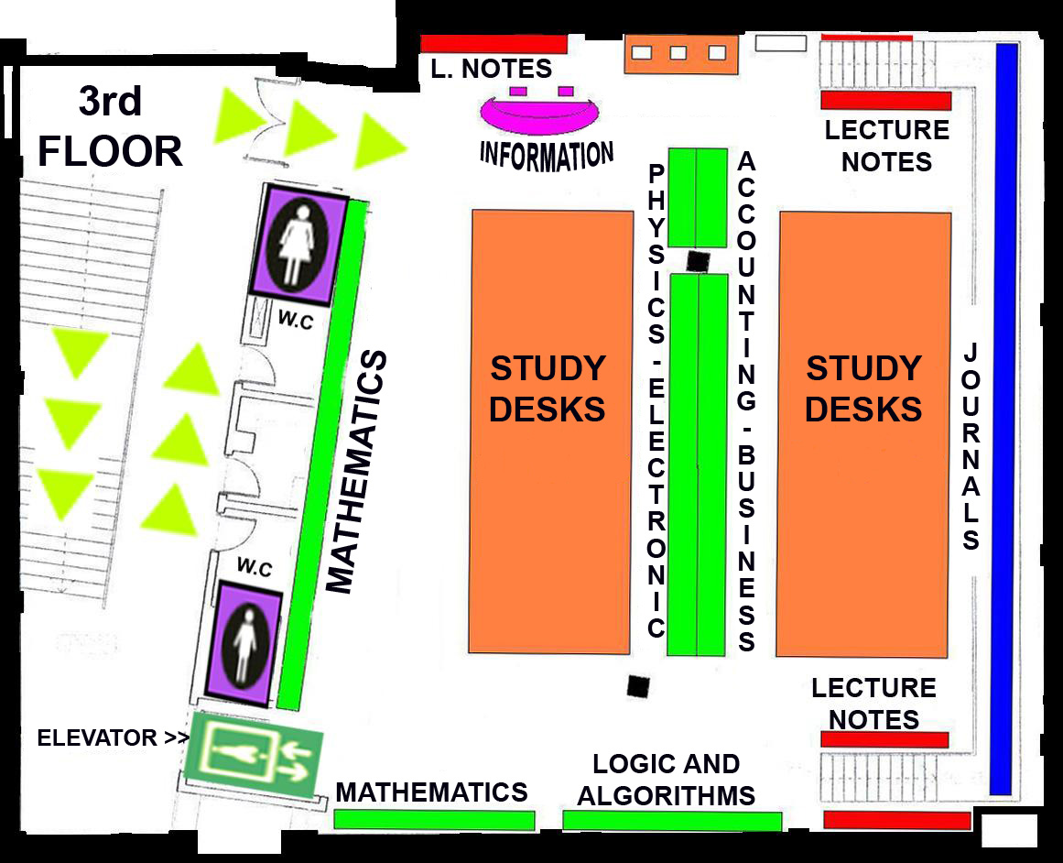
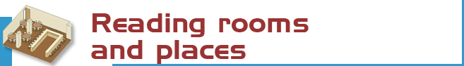
Reading rooms and places
We have 257 reading places distributed as follows:
1st FLOOR: Loans
- media room: 47 computer desks
- 3 rooms for work groups: 18 places
- reading: 12 places
2 ^{nd} FLOOR
- reading: 92 places
3 ^{rd} FLOOR
- reading: 88 places

• Open access monographs (catalogue  code M): 12.296 items.  • Journals (P): 297 titles.  • Lecture notes (LN): 2,561 items.  • Special materials (CD, DV, DQ, VI,  CDP): 3,981 items.  • Unique collections kept in display cabinets (V): 1,749 items.  • Books in the deposit collection (D):  4.142 items.  • Reference (R): 300 items.  • Brochures (F): 790 items.  • Librarians’ resource materials (BT):  130 items.  • Theses (T): 89 items.  • Coursework (TC): 518 items.  • Master projects (MA): 135 items.  - Science Fiction (N): 700 items. | • Movies (O): 687 items.  • Computer games (J): 67 items.  - Comics (C ) : 38 items  • E-readers & e-Tablet (LE): 9 & 3 items.  • Laptops (PO): 18 items.  • Desktops (PCBCA): 7 items.  - Electronic books: more than 10.000  The catalogue code indicates where the title can be found.  For example, M 004.65 KOR  - The first letters indicate the collection  (in this case M stands for open access  monographs)  - the numbers show the subject  (004.65: Databases)  - and the last letters represent the author  (KOR: Korth, Henry F.).

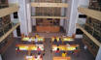 | The Complutense Library is the biggest university library in Spain, with 30 faculty libraries, 9,700 reading places, 3,000,000 of titles, 1,000 computers, and most importantly a staff of 517 people at your service.




COMPLUTENSE UNIVERSITY OF MADRID Library

www.ucm.es/bucm/eis

guide | 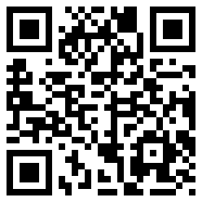  Computer Science

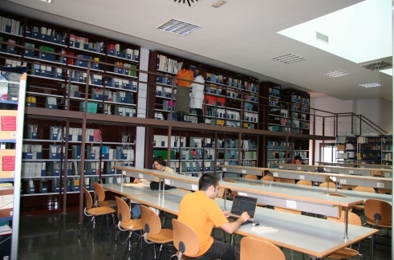
LIBRARY HOURS:  School days: 09.00 to 21.00.  Special timetables apply during exam periods, Christmas, Easter and in summer, to be announced in advance.  Address:  C/Profesor José García Santesmases s/n Ciudad Universitaria  28040 Madrid  Tel:  • Library Information: 913947523  • Loans: 913947523  • Inter-library loans: 913947523  • Technical procedure: 913947523  • Sub-directorate: 913947522  • Directorate: 913947521  Fax: 91-3947524  E-mail: buc_eis@buc.ucm.es | Transport  METRO  - Line 6: Ciudad Universitaria.  E.M.T. BUSES  - Lines F, G, U, I, 82, 83, 132  and 133

More information and forms available at the help desks
and on our website: www.ucm.es/bucm/eis

September 2011



Who. All members of our university community may use all our services, take out books on loan and access our online collections off campus. Members of the UCM Alumni Association and Friends of the UCM have access to some of our services such as home loan.

Our materials can be used by everybody in the reading rooms (restrictions may be in force during examination periods). Visitors who wish to use other services or borrow books must be recognised by a professor or by the Director of the Library by means of a valid library card, which is personal and non-transferable. For some services a PIN number is required.

Improper use of materials or inappropriate behaviour towards our staff or other users constitutes gross misconduct and will be dealt with by academic or legal authorities (Library Rules).



The library organizes occasional guided tours and by prior arrangement to further awareness of its services.

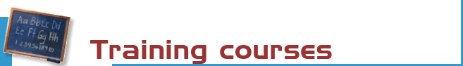

The library organizes free courses on the use of its online resources.
More information regarding membership, etc. can be found at the help desks and at buc_eis@buc.ucm.es

Courses:
- Use of catalogues, databases and online journals.
- Advanced use of information resources for research in information technology and related sciences.
Our website offers guides for using our resources.



Books: the most recent and in-demand titles can be found in the open access rooms (codes M on the 2nd and 3rd floors and LN on the 3rd floor). Earlier titles are in the deposit (code D) or display cabinets (code V). Please request these at the loan counter. There is also an open access science fiction collection (code N on the 1st floor).

Journals (code P): the latest numbers are available on the journal display shelves on the 1st floor. Earlier copies can be found on restricted access shelves and should be requested at the loan counter.

CD-ROM, DVD and other materials: (codes CD, CDP, DQ, DV, J, LE, F, PCBCA, PM, PO, VI, and T) can be requested at the 1st floor counter.

For other materials please consult: www.ucm.es/bucm/eis



Purchase requests. Please let us know which titles we should acquire to complement our catalogue, or which titles need more copies.

Complaints or suggestions. You may complain or make suggestions in person, or by e-mail. We will contact you as soon as possible.



We are making every effort to ensure that our premises are adapted to the needs of disabled persons. JAWS and MAGIC software is available for sight-impaired users. More info at buc-discapacidad@buc.ucm.es
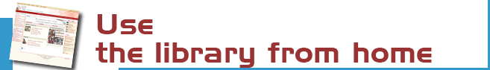

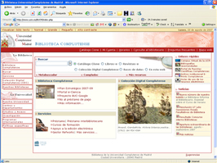 | Our website enables you to:  - Renew and reserve loan books.  - Access our online collection (books, journals, theses, databases …).  - Consult a librarian.  - Use guides.  - To keep informed and participate via our blogs.  - And much more ...  Some services require PIN.


You can use our online service to find out about availability of your course bibliographies.

The Complutense Library will arrange special opening hours at some libraries during examination periods (Saturdays, Sundays, at night).


Loan conditions:  Reference books (encyclopaedias …), journals, unpublished theses, and works of special value cannot be taken out on loan.  Fines:  One day for each day overdue.  Library Hours: From 9.00 to 21:00. | Deadlines and number of titles:  - Students: 8 titles (15 days).  - Researchers and administrative  personnel: 20 (1 month).  - Teachers: 35 (2 months)  - Students Double Degree: 12 (15 days)  Renewals and reserving.  Reservations and renewals of books in the catalogue may be made using your PIN.



Our computers are available for public use to access the Internet and search our online collections. 18 laptops are also available, as well as 9 e-readers and 3 tablets. The library offers Wifi Internet access through the UCM network.
Library Hours: from 9:00 to 21.00



A photocopier is available for public use. We remind users that maintenance of this machine is the responsibility of the subcontractor.



The bibliography service can help you find referenced books and documents.
Stay up to date by subscribing to the e-mail summary and new additions service.



We can obtain documents from other national and international libraries which are not in our collections.



If you would like to publish your research online we can help you through our electronic publishing service.
Working with the UCM Publications Service, we will arrange to publish your theses, journal articles, pre-prints and books: ISBN management …
(buc-edición@buc.ucm.es)

